**Linux and cloud exam**

**Hrithik Roy**

**240840325028**

**Step1.>**

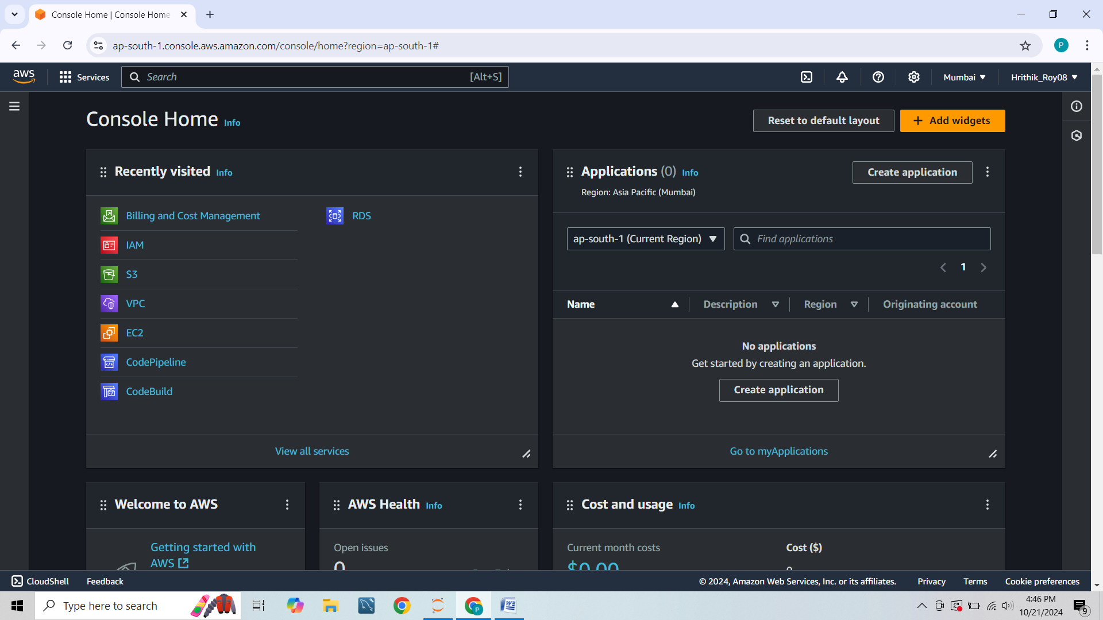

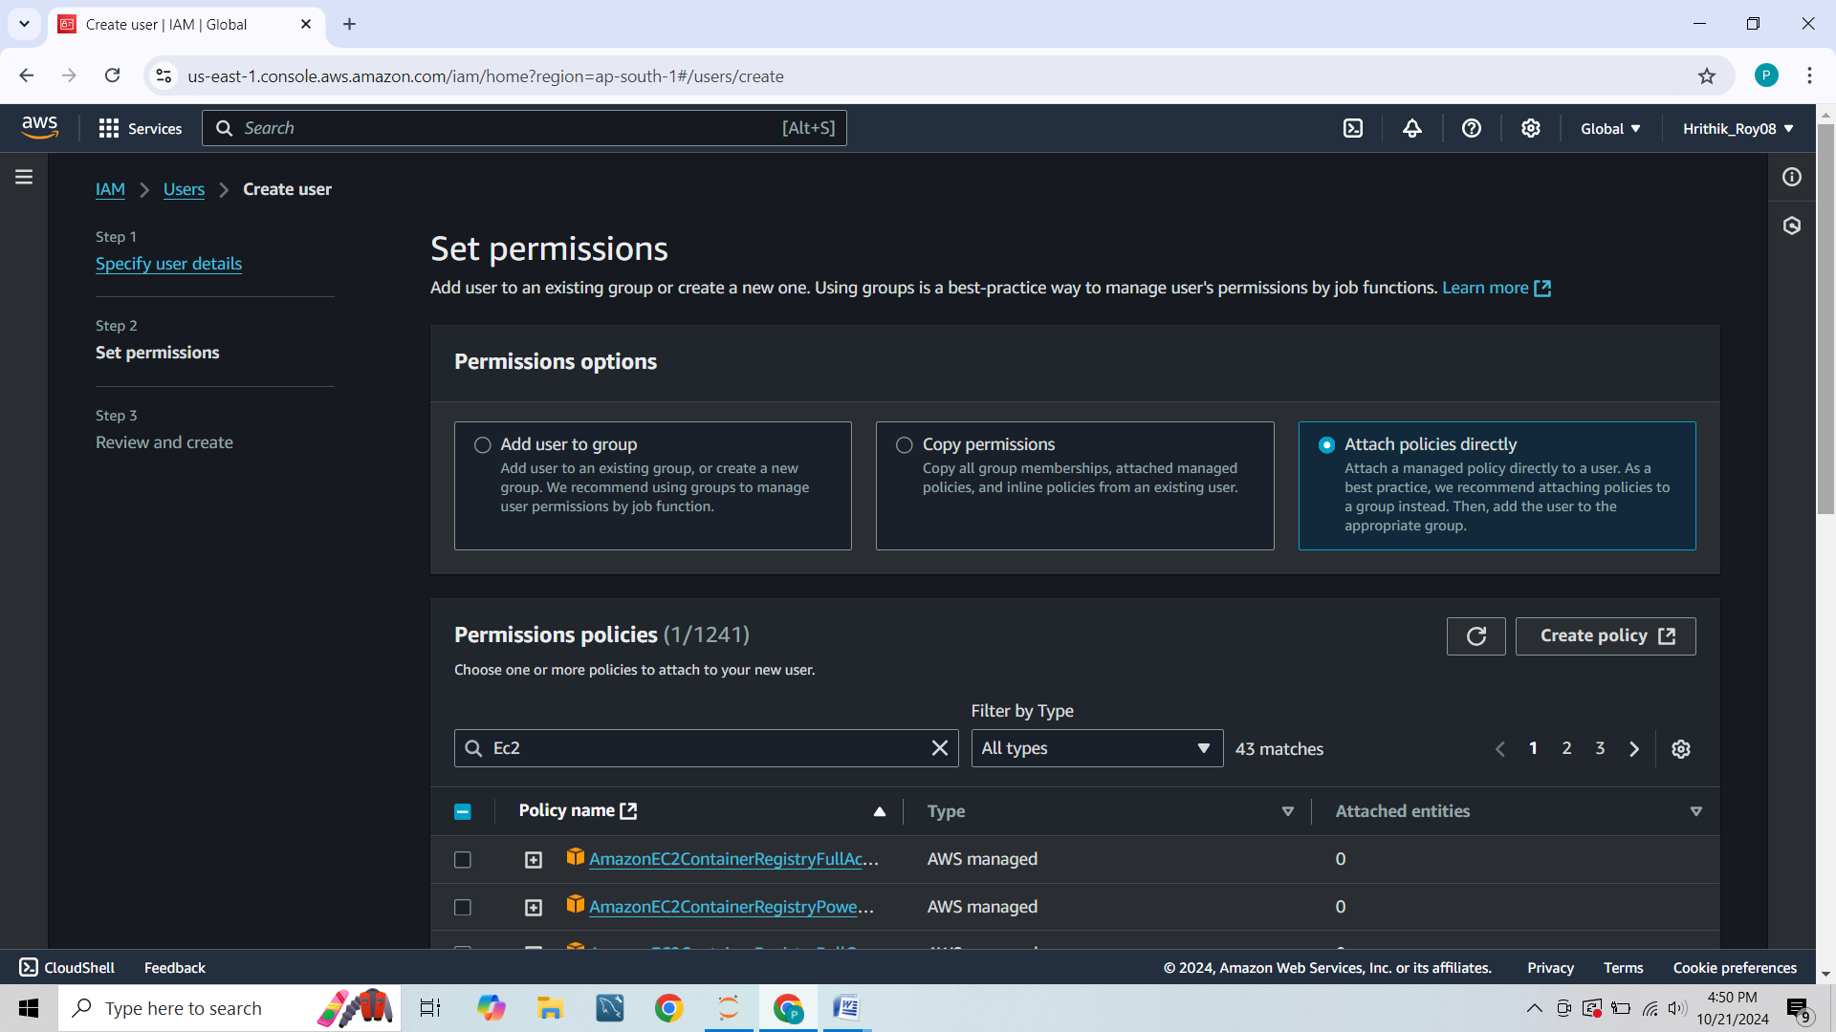

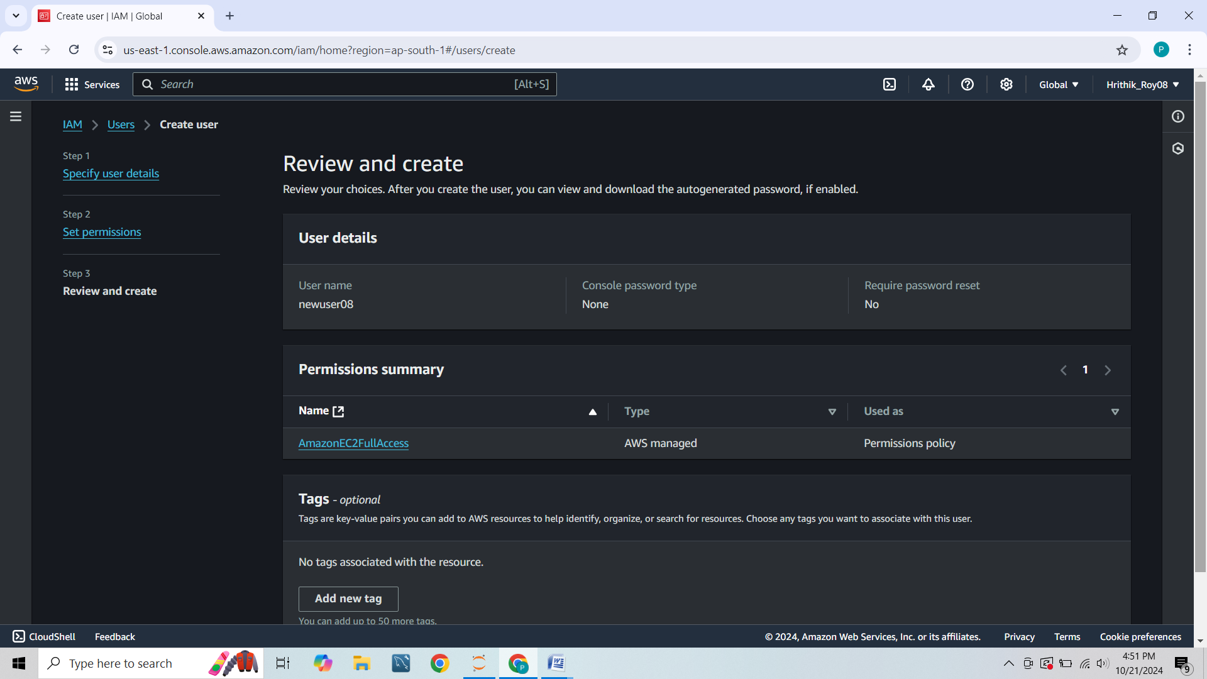

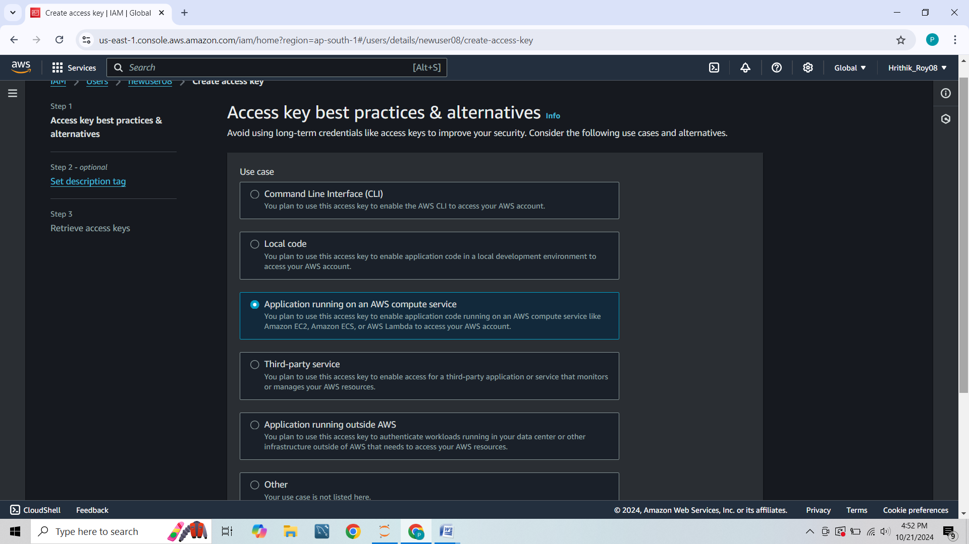

[**https://816069125931.signin.aws.amazon.com/console**](https://816069125931.signin.aws.amazon.com/console)

**Link for another IAM created**

**Username---newuser08**

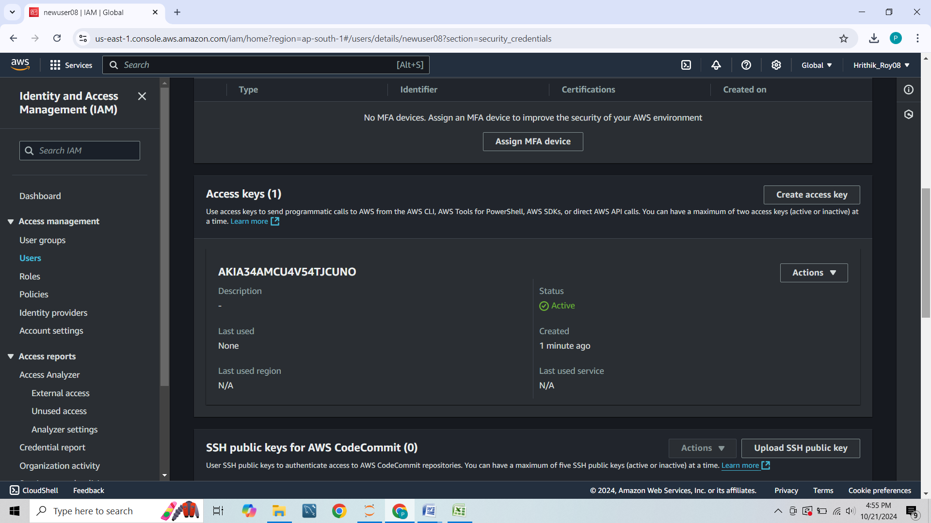

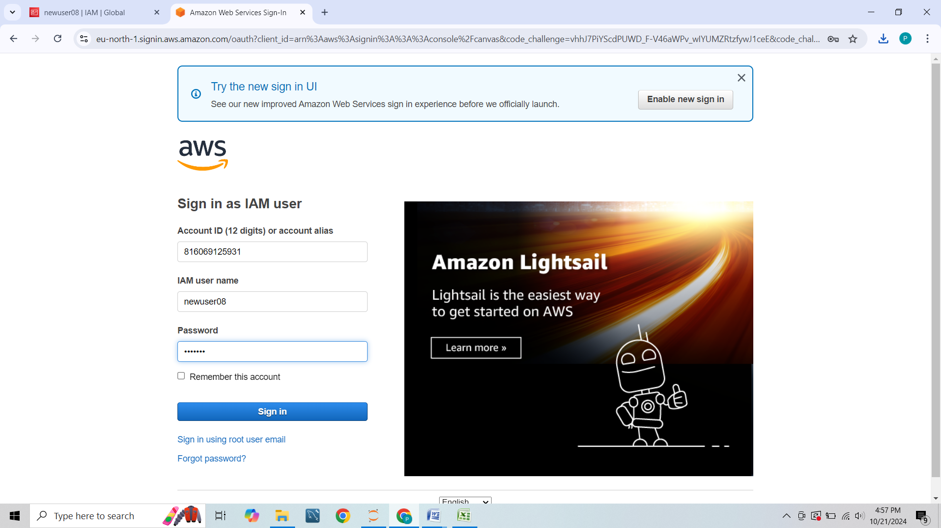

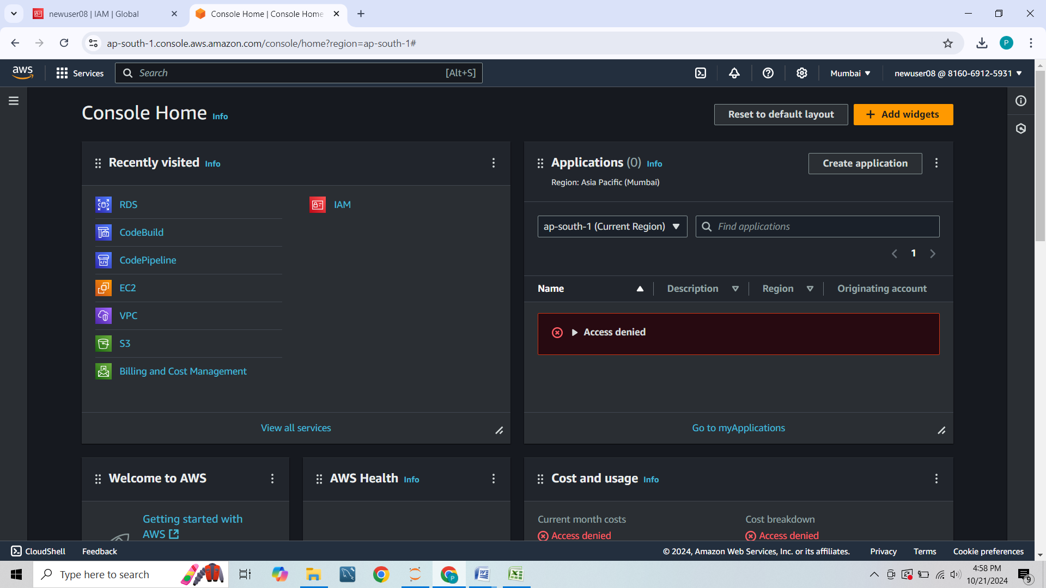

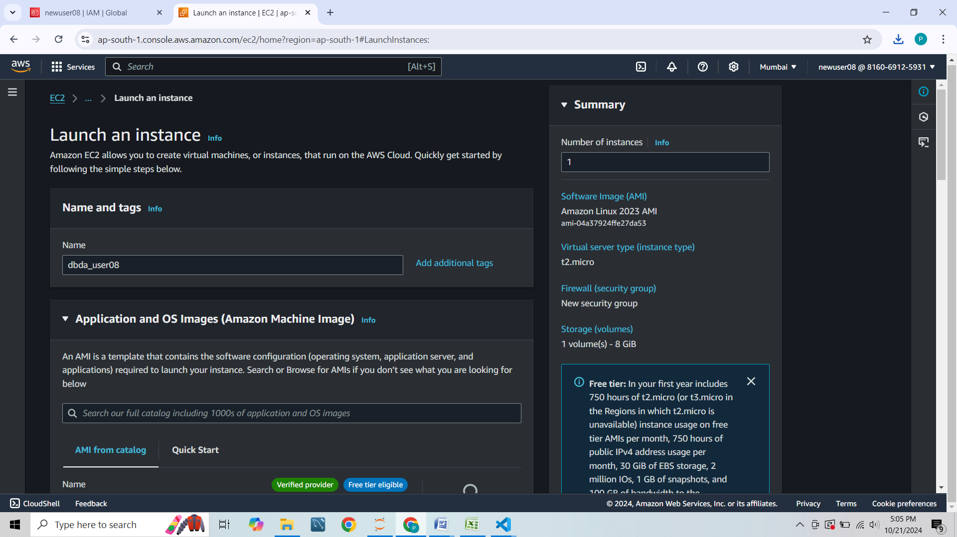

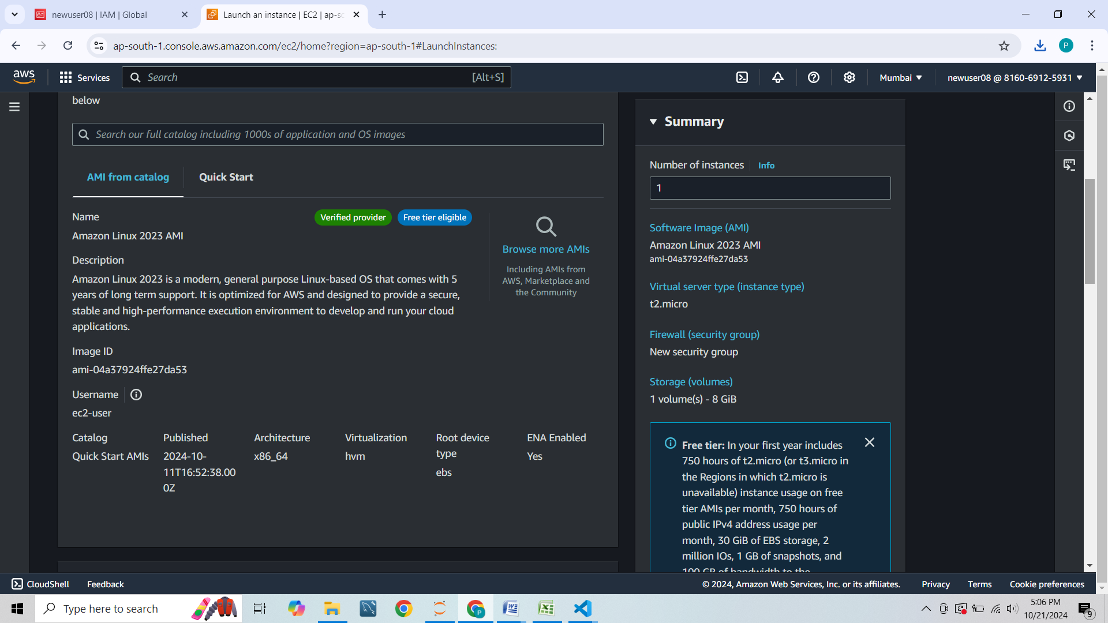

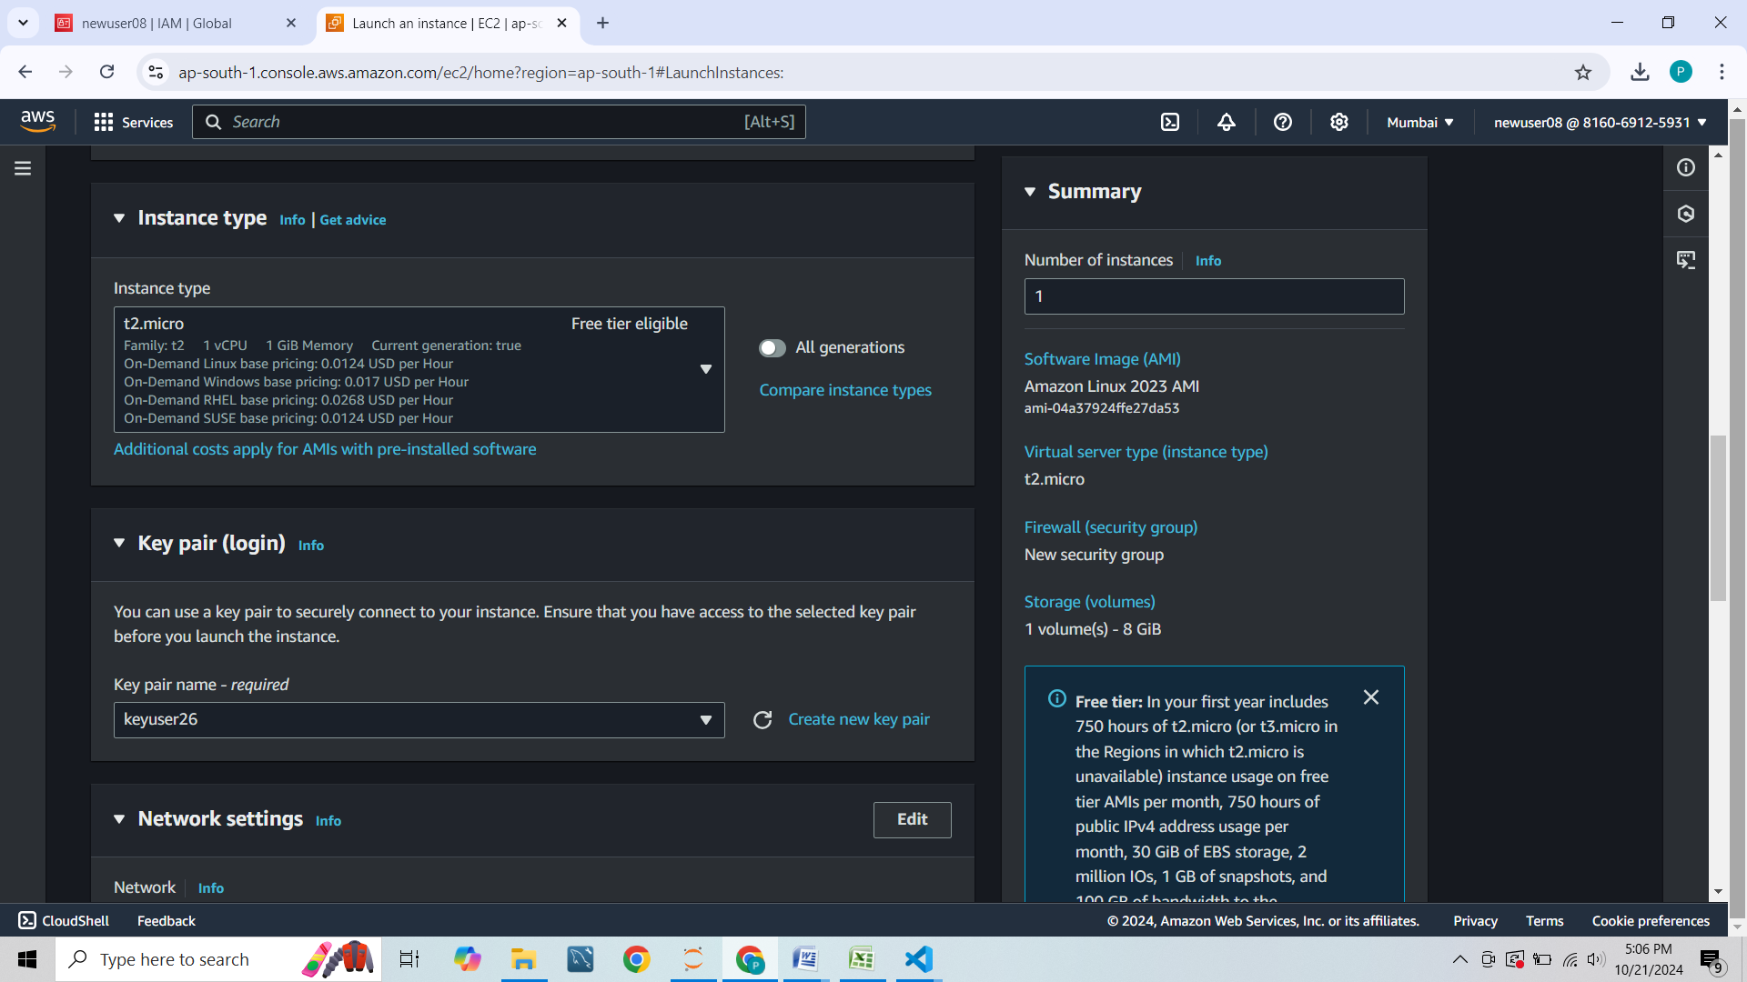

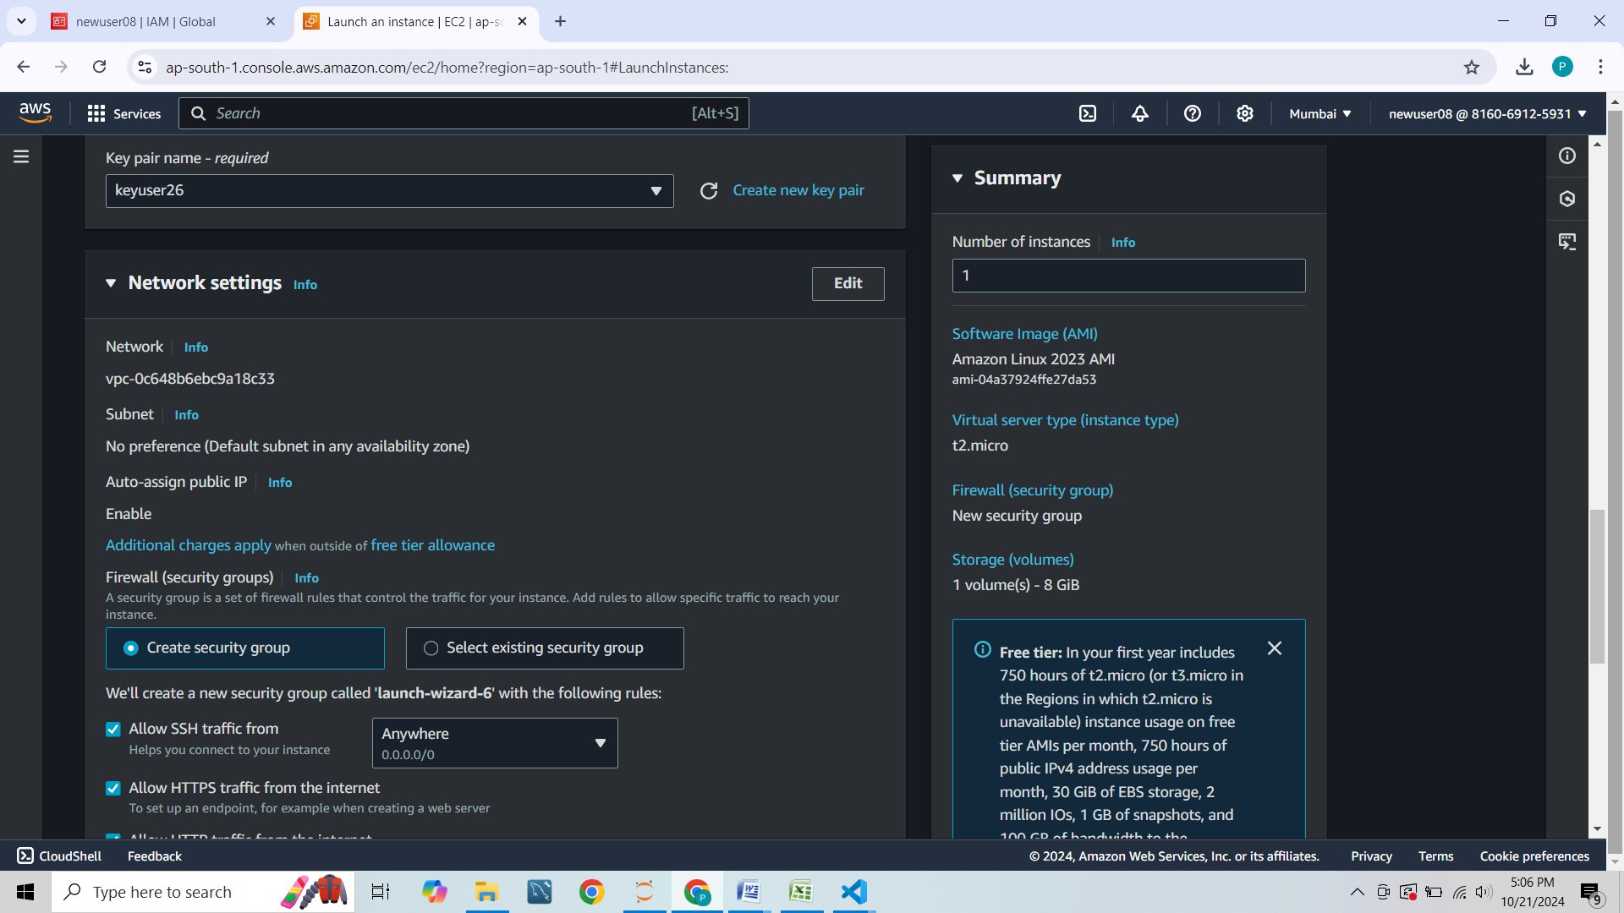

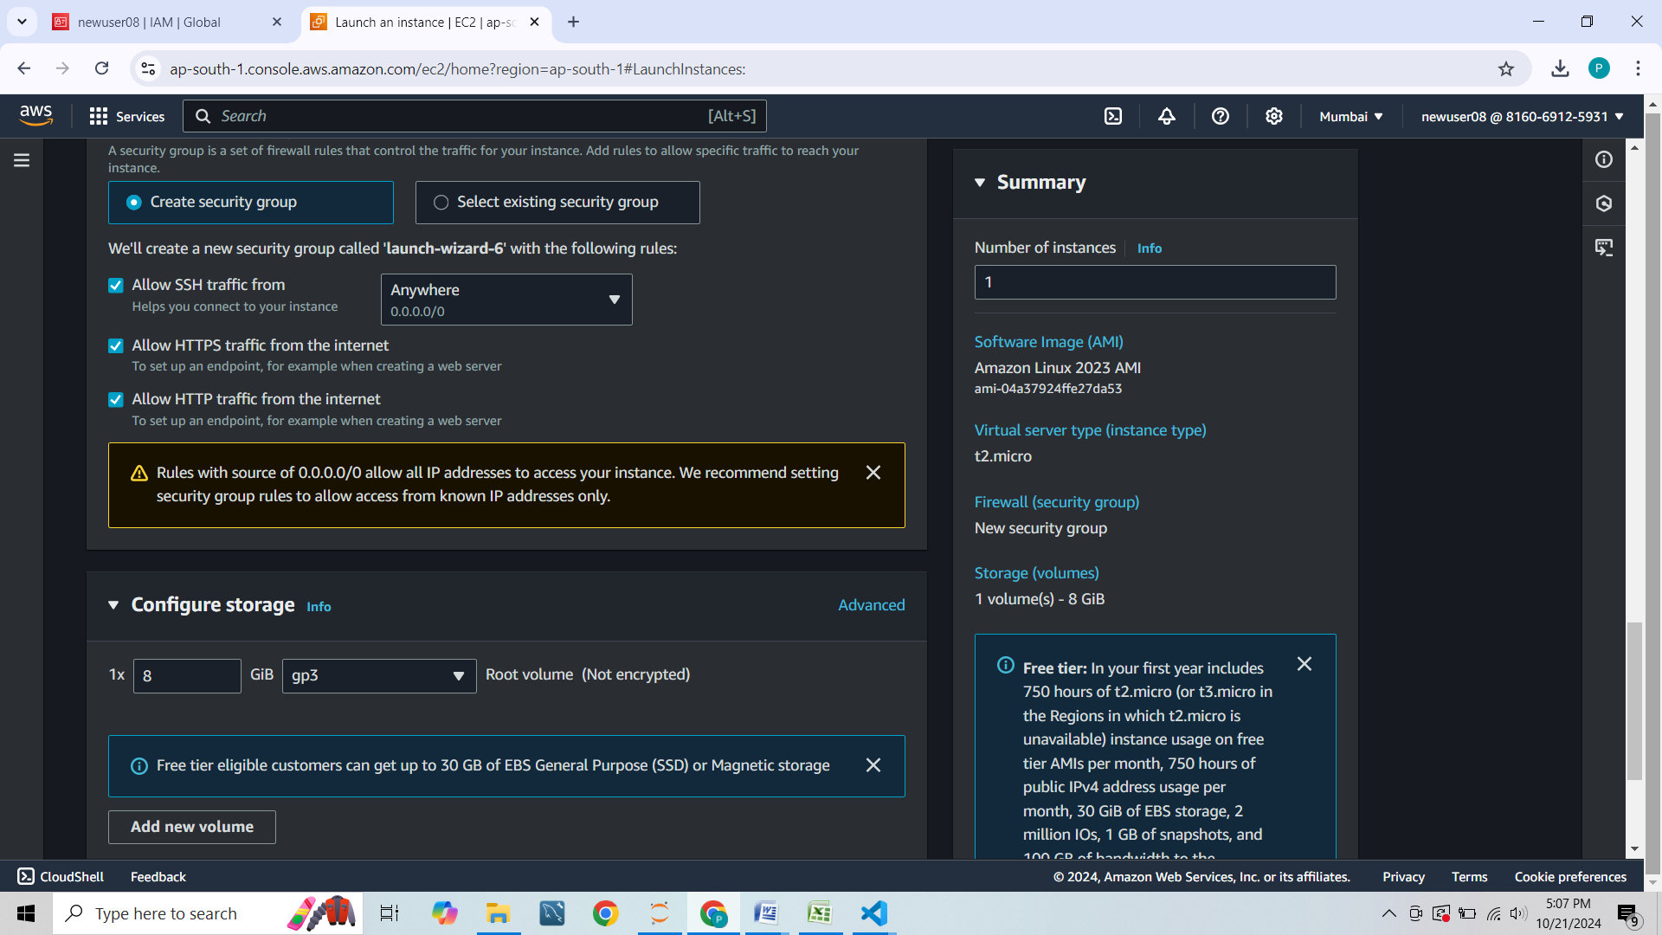

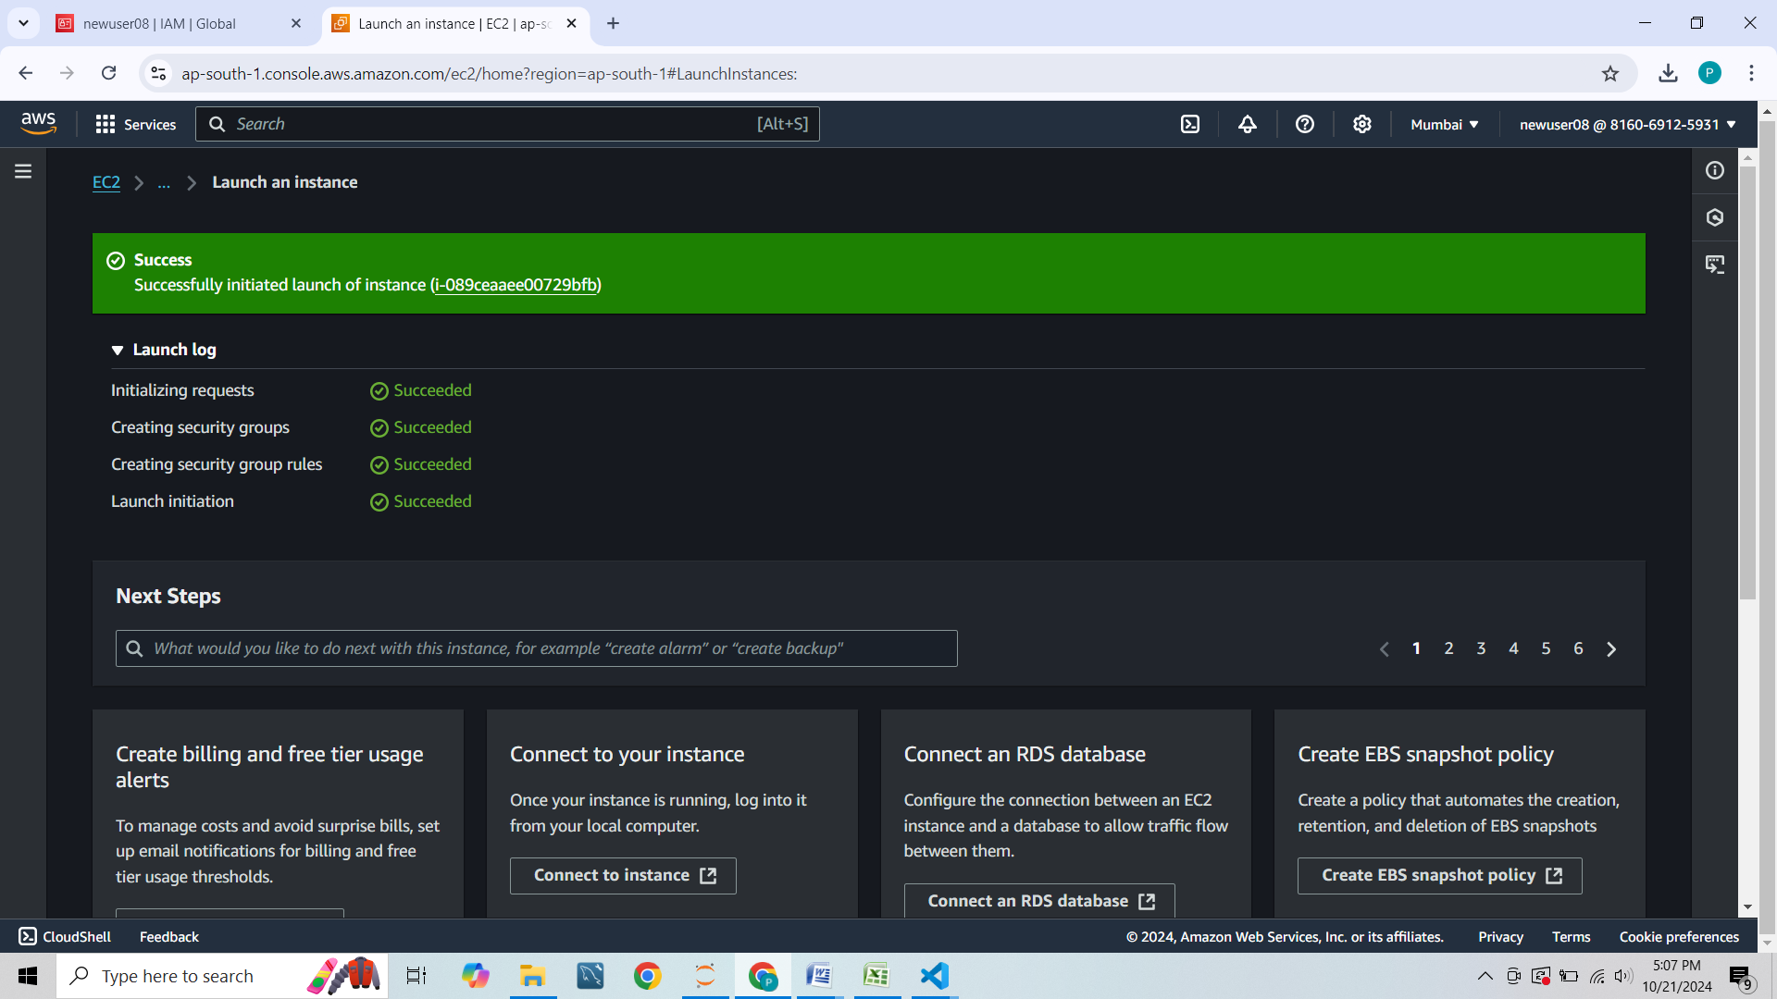

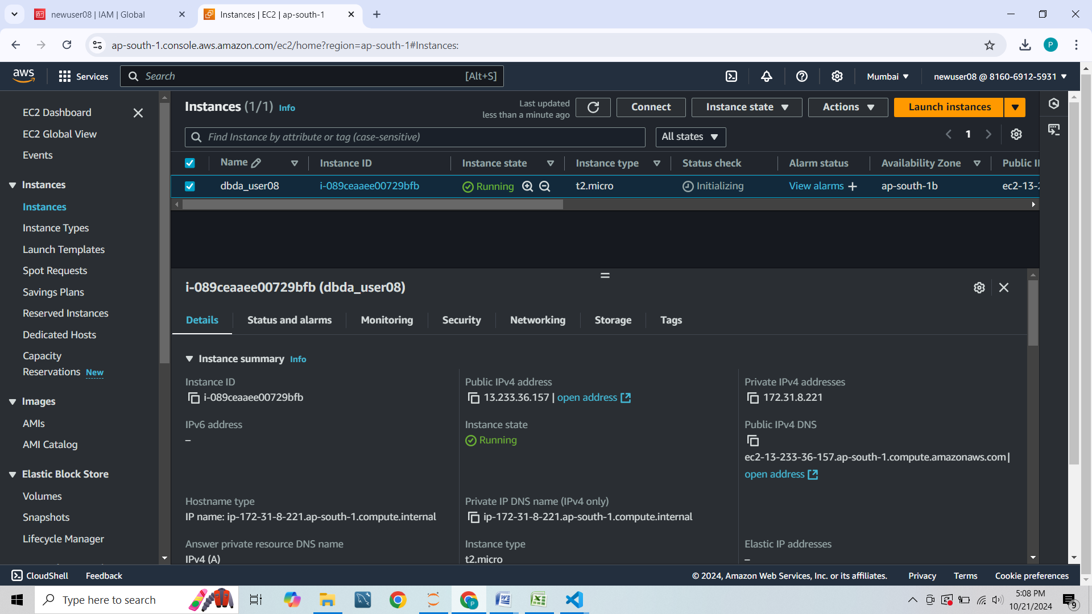

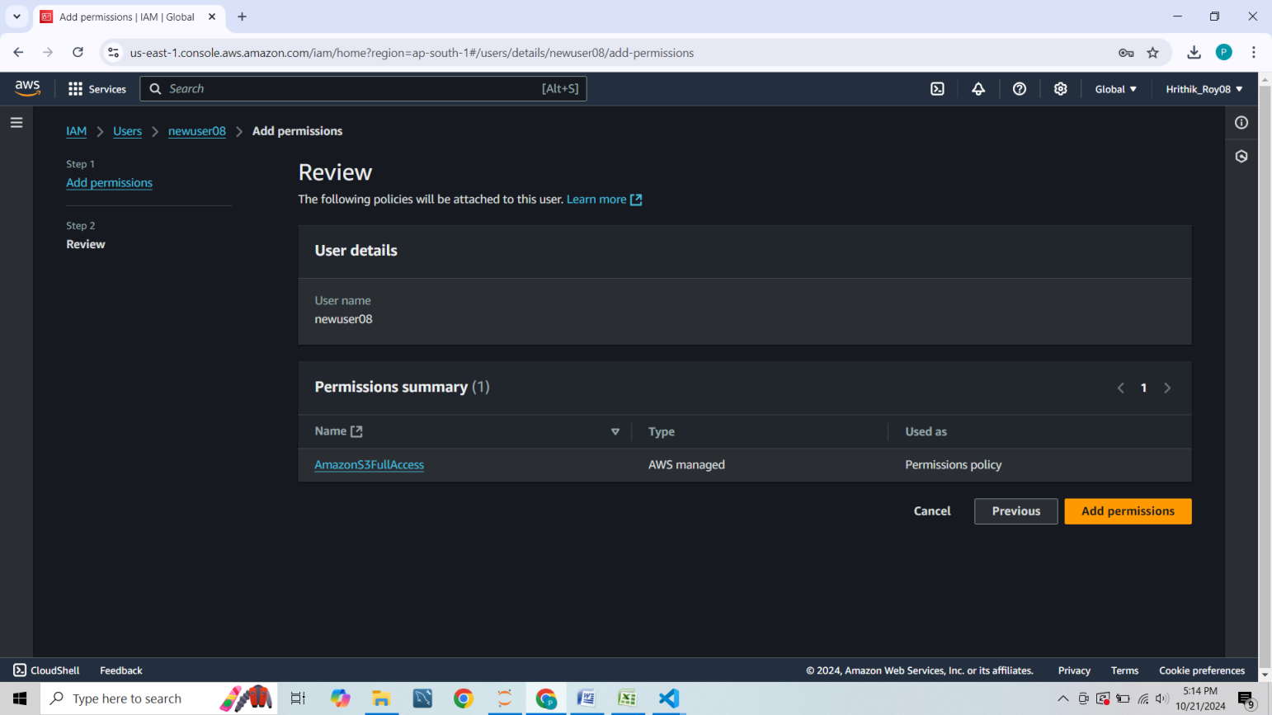

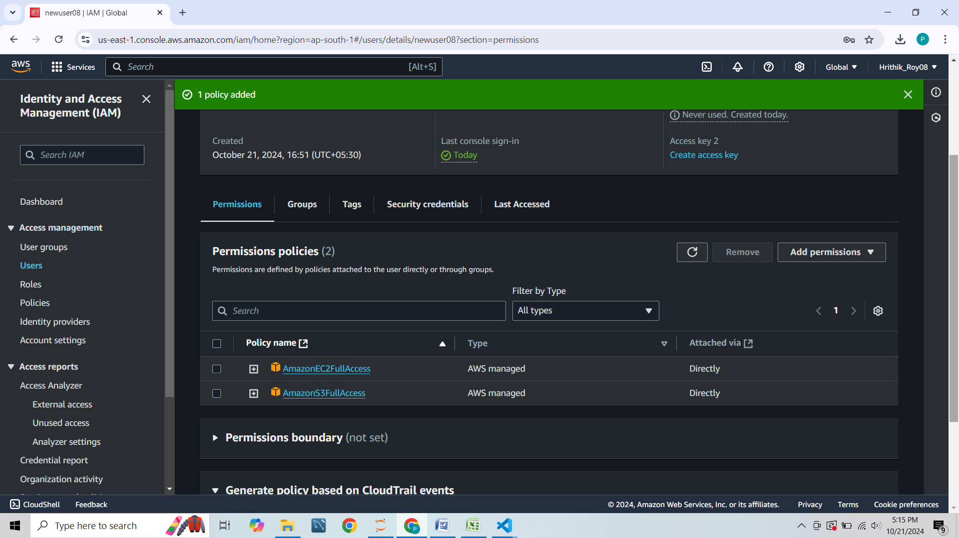

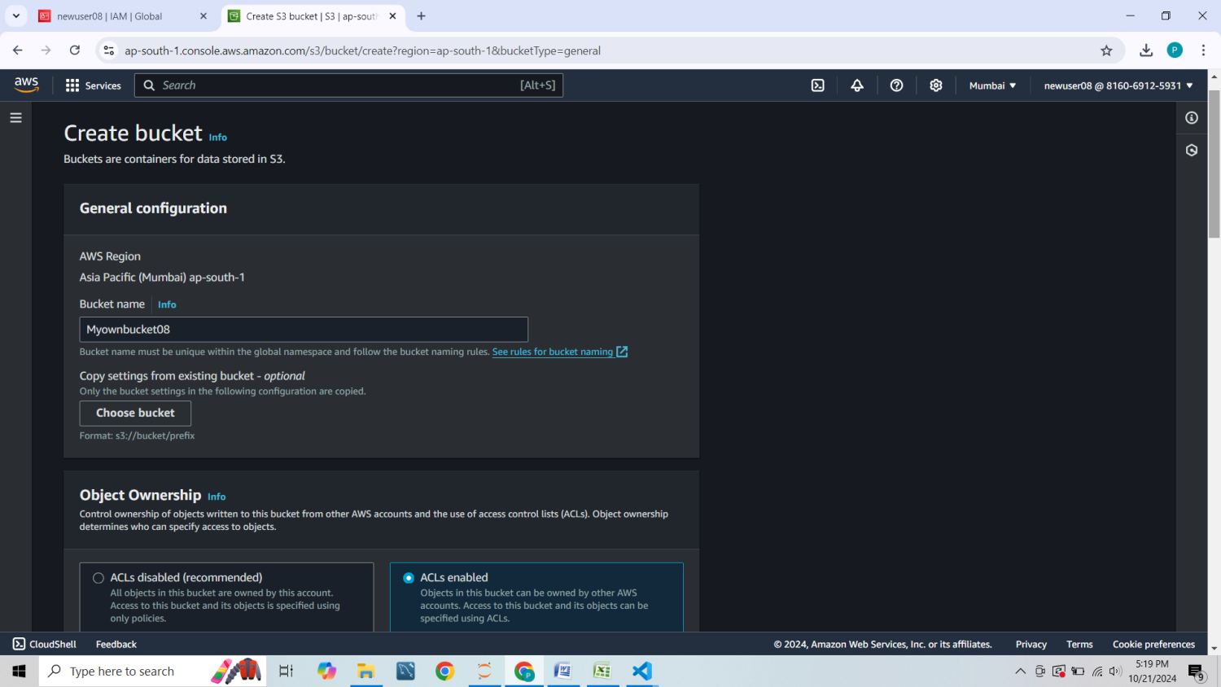

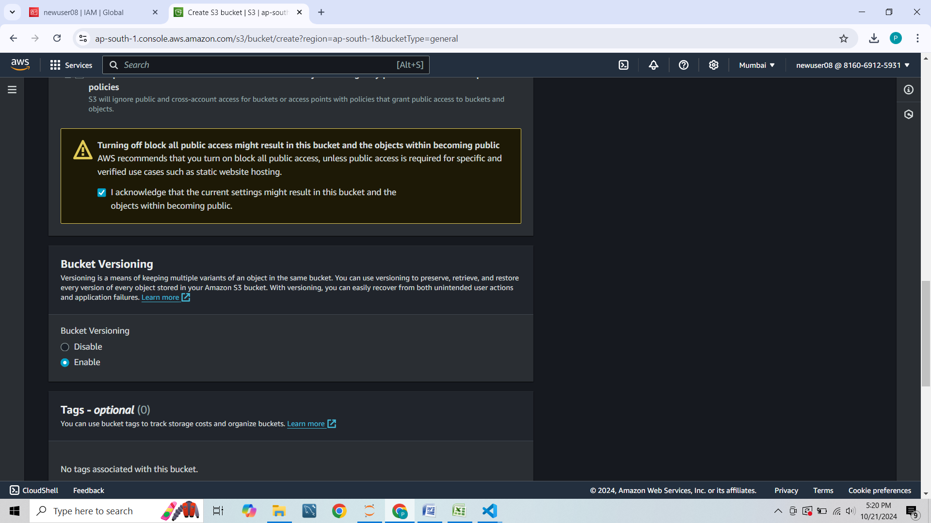

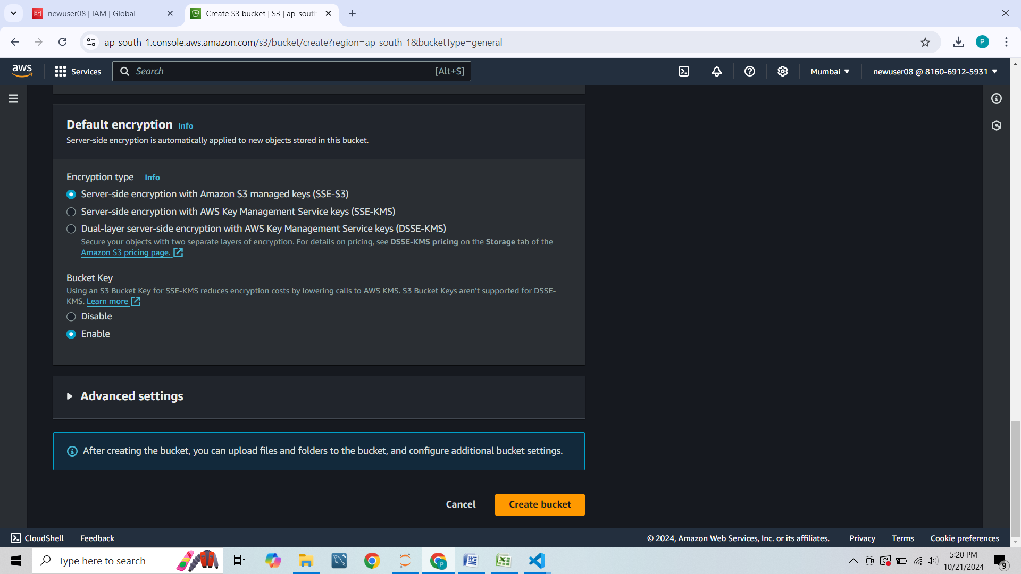

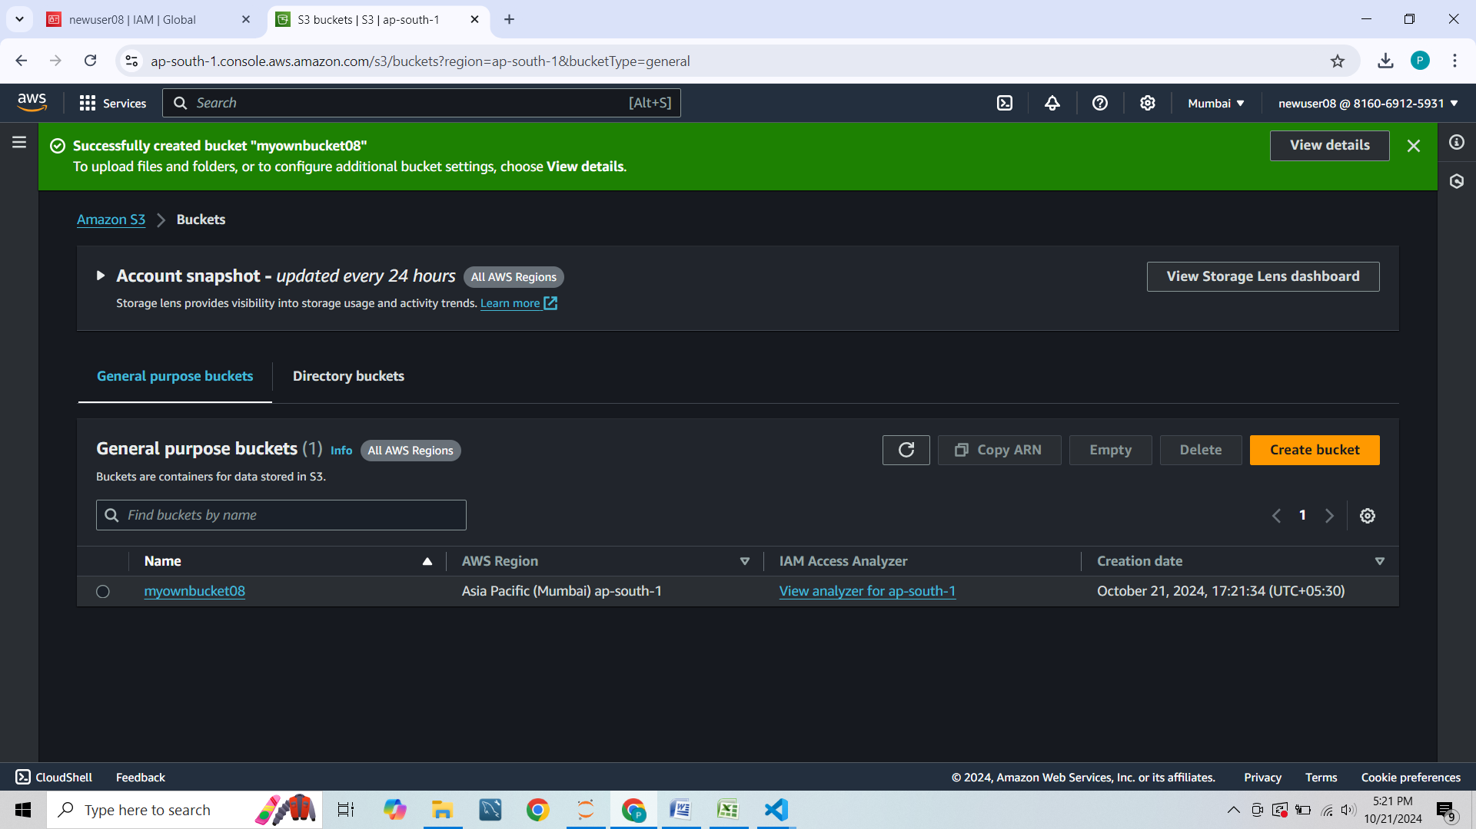

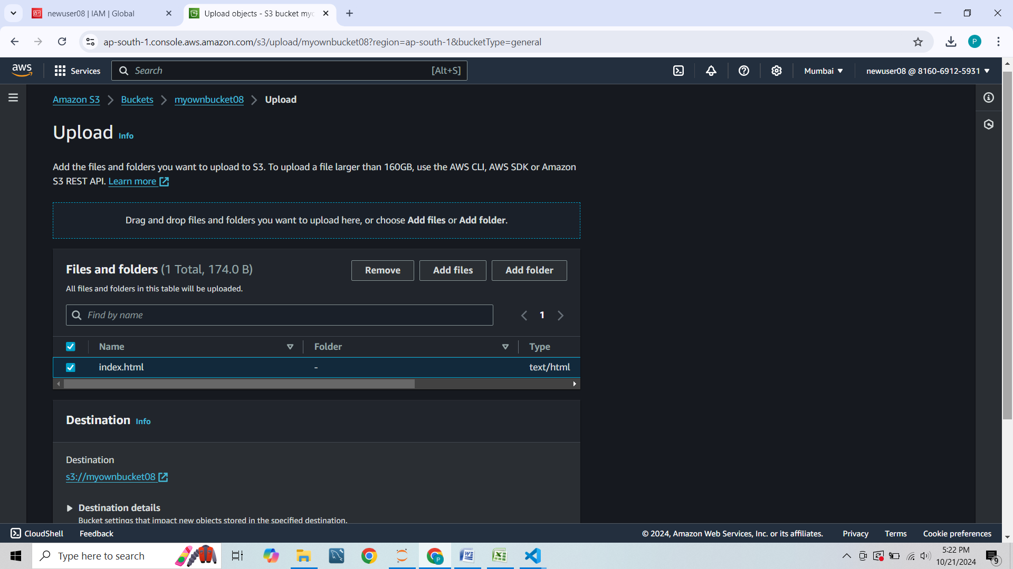

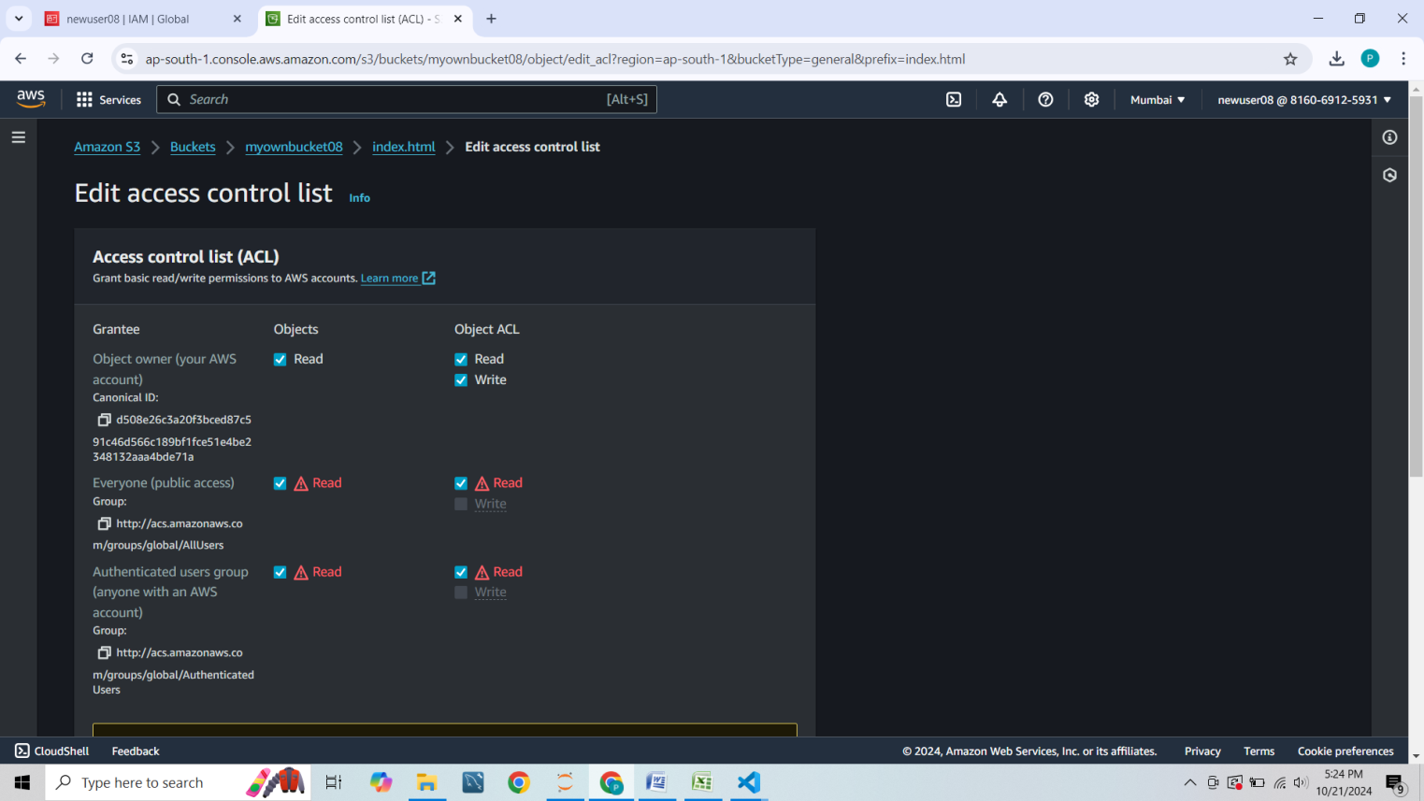

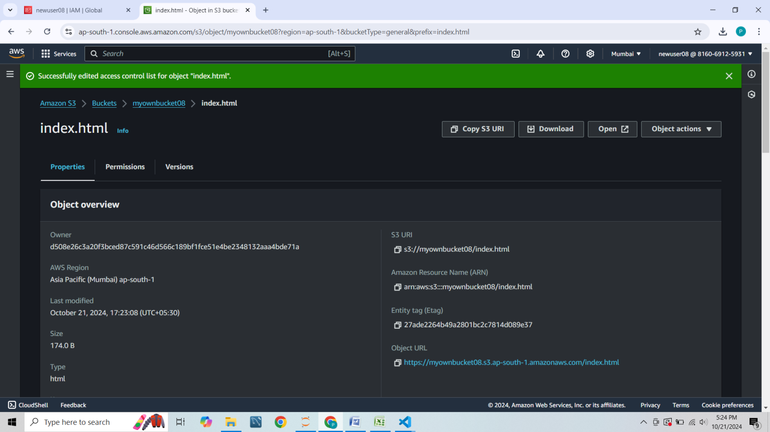

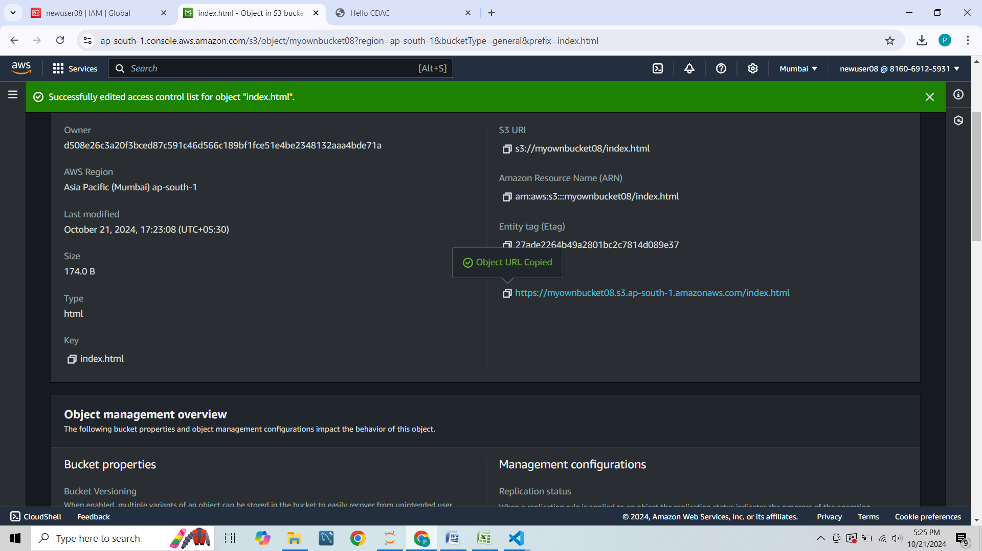

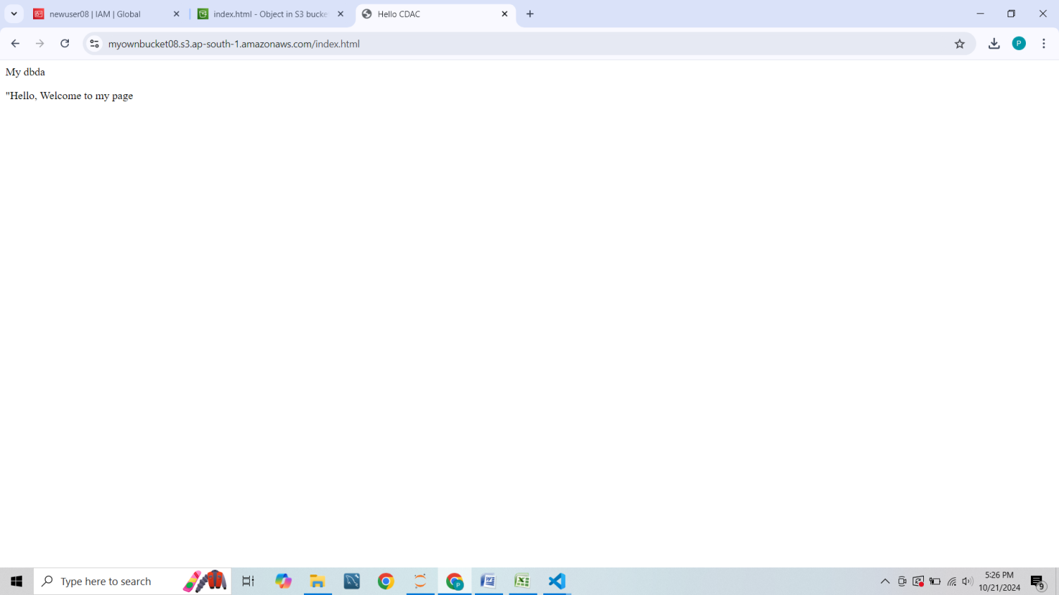

**The below is the link**

**____________________________________**

[**https://myownbucket08.s3.ap-south-1.amazonaws.com/index.html**](https://myownbucket08.s3.ap-south-1.amazonaws.com/index.html)

**-------------------------Linux---------------------------------**

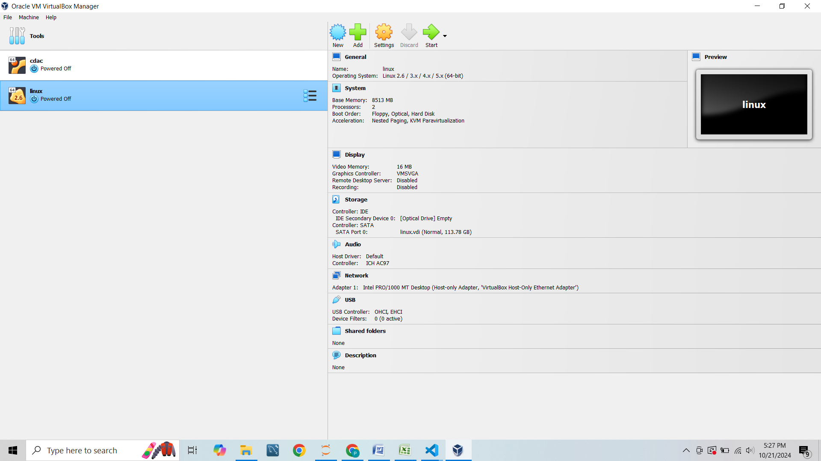

**Q2.>-----------------**

**mkdir roy -- directory created**

**ls ---- for checking the directory existing or not**

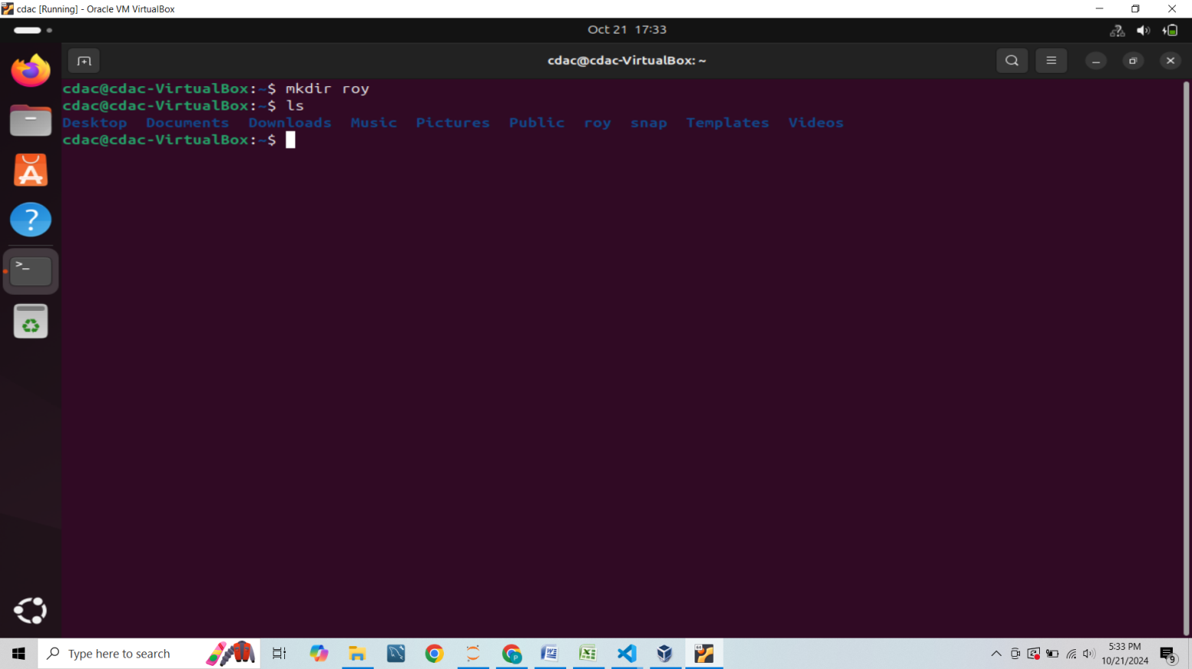

**s**

**Used move command to moving one file from one location to another-----**

**mv roy root35**

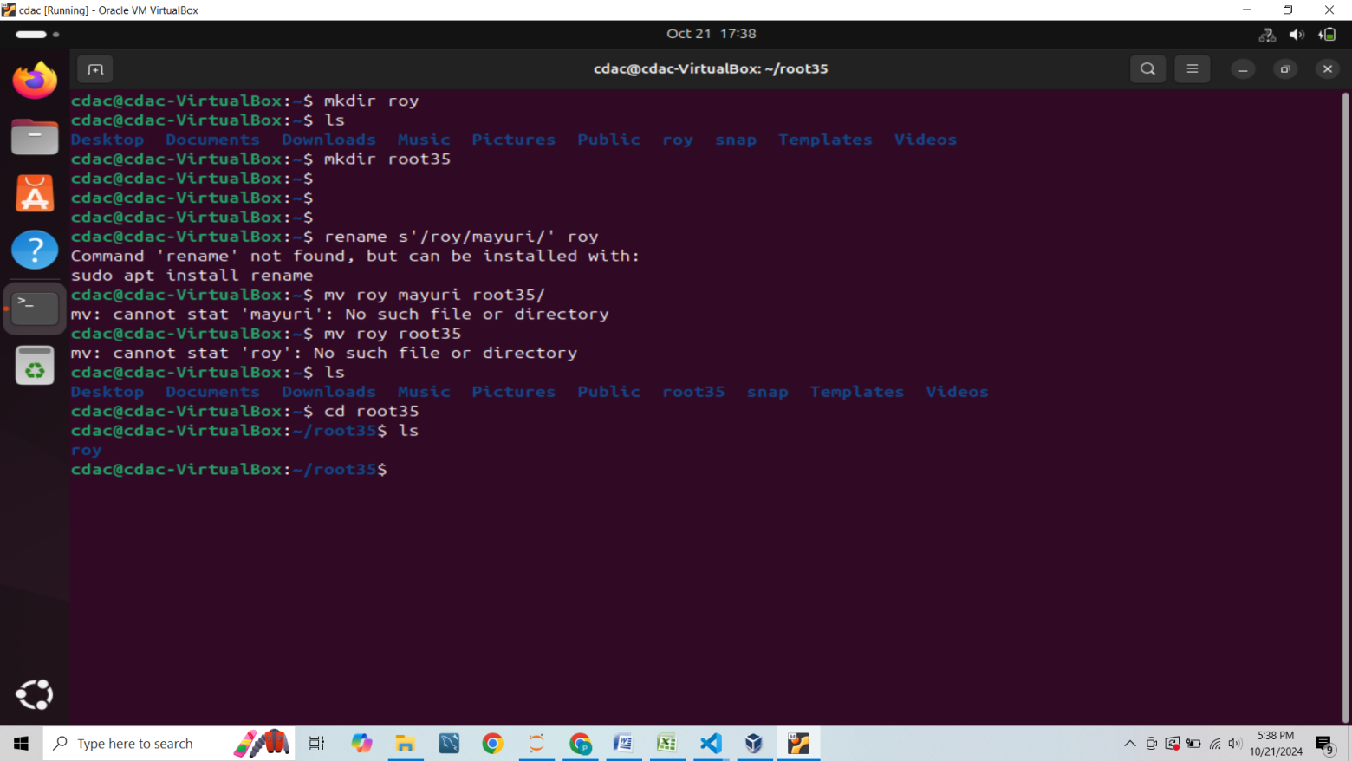

**Gone first to the directory of root35 then**

**Written command ---**

**cd root35**

**rmdir roy**

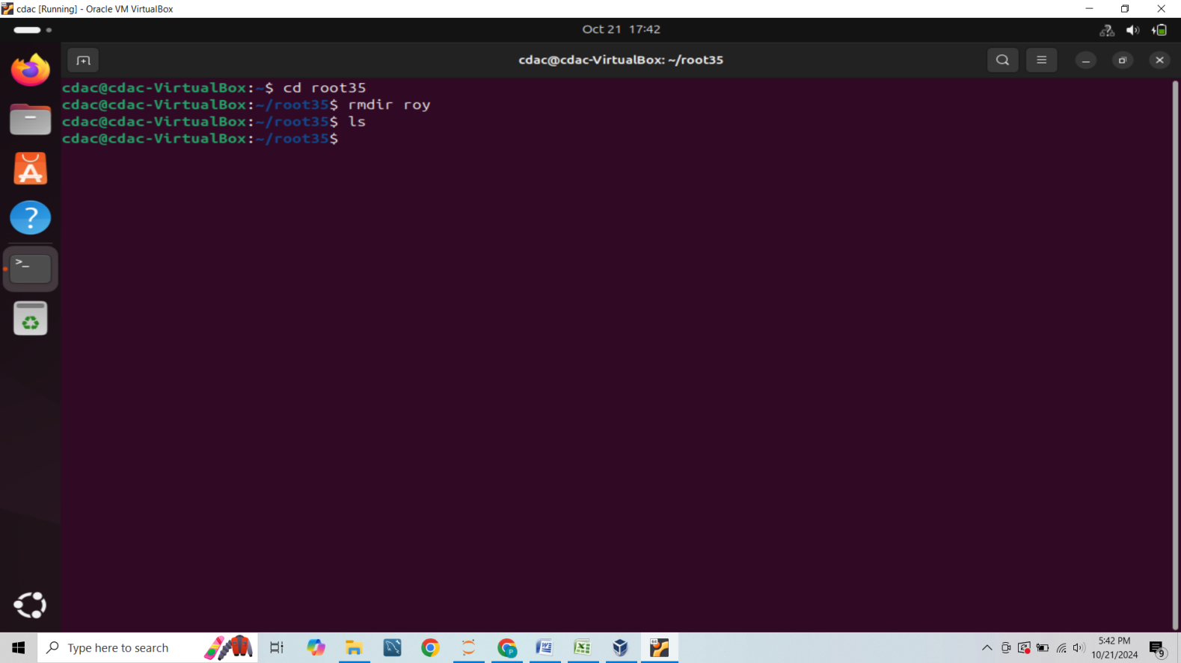

**Now removed root35 by giving commands as**

**rmdir root35**

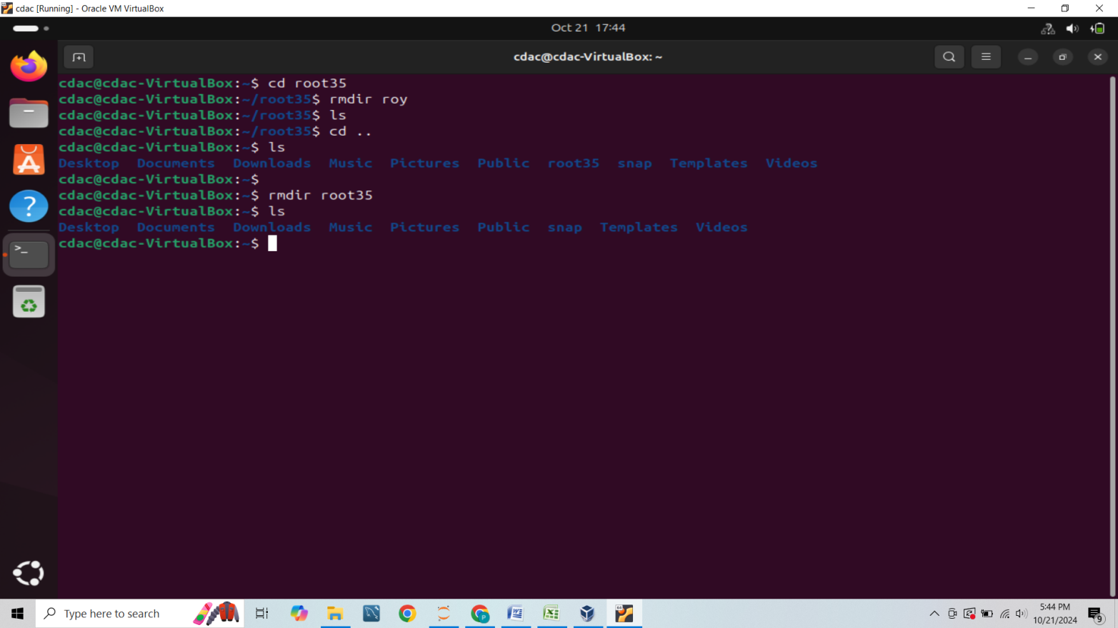

**Q1.>**

1. **Display the largest among the numbers.**

